Working document
For the EHII MS
On behalf of the Working Group on Indicator Mapping

Question 1
A possible outcome of the WG could be a “working agenda” summarising concrete issues per indicator set or indicator topic that need to be tackled in order to
-reduce the data reporting burden (i.e., to support data collection, see Fig 1)
-increase health reporting consistency and quality (i.e., to support health reporting, see Fig 1)
starting with alcohol consumption, life expectancy, vaccination coverage, see 10th SG meeting report.
Would you support the WG working on this or would you have other suggestions on how to proceed with this work?

For an example of such a working agenda, see Annex, Table 1.

Question 2
Which indicator characteristics would be most relevant/important for your country to focus on (which would likely yield most impact) when thinking about harmonising/aligning over the three organisations?

For a list of the characteristics reviewed for the first three indicators, see Annex 2, Table 2.

Fig 1: from data collection to evidence-informed policy making

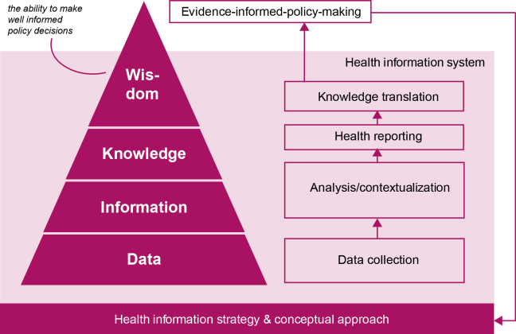

Annex 1:

Table 1: Fragments of a possible working agenda to be delivered by WG
Alcohol consumption | Description of basics and issues | Discussion
Conceptual | 1. any consumption vs 2. health impact | Purpose of concepts clear and useable?
Any consumption (administrative data sources)
Definition | Unrecorded and tourist/cross border consumption | Feasible to take into account, by harmonised method?
Hazardous consumption (survey data sources)
Semantics | Hazardous, heavy, risky, harmful
Definition | Differences exist, for example  *≥60 g of pure alcohol on ≥ 1 occasion weekly  *average rate of consumption of > 20 grams pure alcohol daily for women and > 40 grams daily for men | What is being measured? (Risk for which health outcome(s)?)  Useful to align definitions in this area?
Life expectancy | Description
Conceptual | At birth vs partial (at specific age) | Purpose of concepts clear?
Age categories | 1, 15, 45, 60, 65, 80 years | Are all categories needed?
Method of calculation | Differences within countries, differences between countries, differences between WHO Human mortality database and Eurostat | Feasible to align methods? More visibility which method is used, by whom?
Vaccination coverage
Conceptual | 1.in children vs 2. In elderly (flu) | Purpose of concepts clear?
Children
Definition | Differences in diseases/vaccines covered,  for example NOT including pertussis, diphtheria, tetanus, mumps, hepatitis B, HPV  Differences in doses, for example fully vaccinated vs at least one dose | Useful and feasible to align definitions under similar aims (such as type of disease to be prevented, adherence to vaccination schedule, attitude towards vaccination)?
Country comparison | There are many differences in country  - primary data sources  - immunisation schedules  - requirements (mandatory vs voluntary)  - targeting (high risk group vs general population) | Need for optimization of data collection?

Annex 2:

Table 2: list of characteristics reviewed
Topic
Sub-topic
Organisation
Data/indicator set
Number
Status
Indicator full name in original data set
International data source
Primary data source
Preferred data source
Data source priorities (in case of >1 possible sources)
Data source type (survey, register, etc..)
Definition
Numerator
Denominator
Data type
Calculation method
Standardisation
Reference population used
Disaggregation requested (list)
Disaggregation available (list)
Statistical reliability
Validity
Specific information on comparability
Start year
Last update
Most recent year
Geographical coverage
MS n
MS data availability
MS data non-availability
Frequency of collection
Difference between requested and actual collection frequencies
Frequency of reporting
Difference between requested and actual reporting frequencies
Time lag of reporting
Purpose/rationale
Relevant policy areas
Actionability
Direction (is it known what increase or decrease means)
Effort: elaborate calculations necessary yes/no
Estimate of costs

At this stage, this is aimed at identifying practical/technical opportunities to harmonize indicator (meta)data between the major relevant institutions and networks in the European Region; improve data sharing; and improve the comparability of indicators between countries (“ first strategy”in 10th EHII SG meeting report). Another (“second”) strategy will focus on work that requires political agreement in order to succeed.
For example: life table covering 1 year or 3 years; closing method last age year + 0.5 yr or Last year + years based on mortality rate, etc.

